Author: Heming Chen

Promotion could increase the category market share temporarily, but it could also have cannibalization effect for the future category sales. Therefore, we would like to know the promotion cannibalization effect for the future three weeks for each category. We build cannibalization models for both grocery and departmental stores, and the code is appended.

For grocery stores we found that retailers do not need to worry about cannibalization for ice cream, face care and novelties which are driven by impulsive purchase or not a destination category for Grocery retailers. But for category such as personal wash, our analysis shows that one more dollar earned by promotion, there would be average 0.1 dollar loss for the total category sales for the next three weeks.

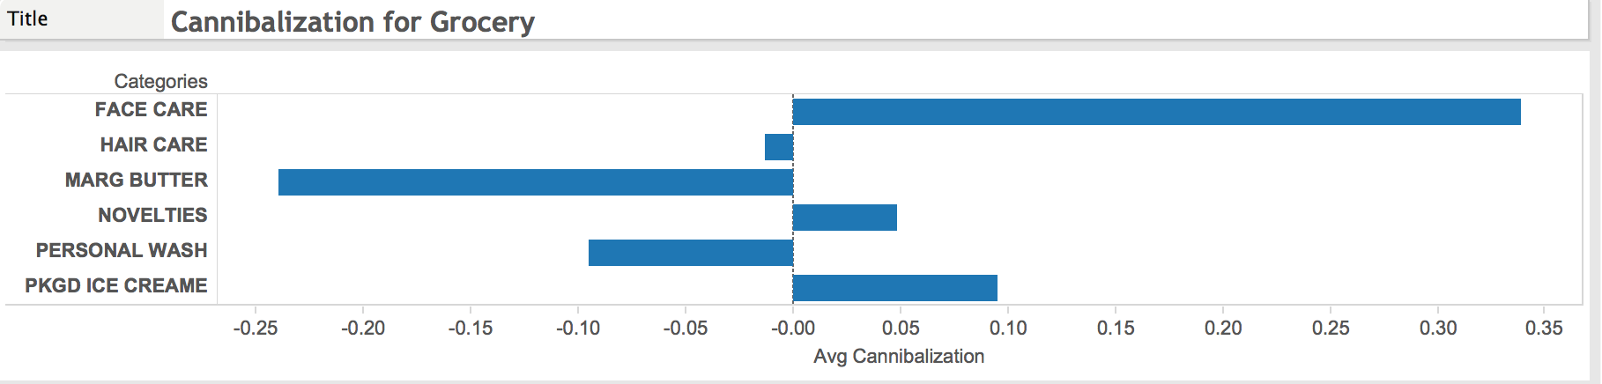

For department store, only ice cream does not have cannibalization effect on future sales.

The recommendation here would be promoting more ice cream to drive consumption

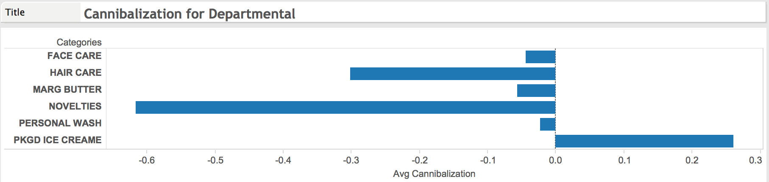

**Appendix Cannibalization**

## next three weeks cannibalization model for cluster 1

```{r}

# compute the next three weeks' total category dollars

cannibalize <- slide(cluster1,Var='CatDollars',slideBy = 1)

cannibalize <- slide(cannibalize,Var='CatDollars',slideBy = 2)

cannibalize <- slide(cannibalize,Var='CatDollars',slideBy = 3)

temp <-cannibalize %>% select(CatDollars1,CatDollars2,CatDollars3)

temp <- transform(temp,p3_catdollars=rowSums(temp))

cannibalize$p3_catdollars <- temp$p3_catdollars

# compute the next three weeks' total category base dollars

cannibalize <- slide(cannibalize,Var = 'CatbaseDollars',slideBy = 1)

cannibalize <- slide(cannibalize,Var = 'CatbaseDollars',slideBy = 2)

cannibalize <- slide(cannibalize,Var = 'CatbaseDollars',slideBy = 3)

temp <-cannibalize %>% select(CatbaseDollars1,CatbaseDollars2,CatbaseDollars3)

temp <- transform(temp,p3_catbasedollar=rowSums(temp))

cannibalize$p3_catbasedollar <- temp$p3_catbasedollar

# compute the next three weeks' total promotion(total category dollars for 4 types of promotions)

temp <- cannibalize %>% select(CatDollars_TPR,CatDollars_Display,CatDollars_FeatAndDisp,CatDollars_Feature)

temp <- transform(temp,total_promotion = rowSums(temp))

temp <- slide(temp,Var = 'total_promotion', slideBy = 1)

temp <- slide(temp,Var = 'total_promotion', slideBy = 2)

temp <- slide(temp,Var = 'total_promotion', slideBy = 3)

temp <- temp%>%select(total_promotion1,total_promotion2,total_promotion3)

temp <- transform(temp,p3_total_promotyion = rowSums(temp))

cannibalize$p3_total_promotion = temp$p3_total_promotyion

```

```{r}

# Cannibalization for each type of promotion, keep next three weeks' total categorydollar, next three weeks' total promotion unchanged

attach(cannibalize)

#TPR

Dollarsfix = plm(p3_catdollars ~ CatDollars_TPR + p3_catbasedollar + p3_total_promotion, data =cannibalize, index = c("GEO", "WeekEnding"), effect = "twoway", model = "within")

summary(Dollarsfix)

#Display

Dollarsfix = plm(p3_catdollars ~ CatDollars_Display + p3_catbasedollar + p3_total_promotion, data = cannibalize, index = c("GEO", "WeekEnding"), effect = "twoway", model = "within")

summary(Dollarsfix)

#Feature

Dollarsfix = plm(p3_catdollars ~ CatDollars_Feature + p3_catbasedollar + p3_total_promotion, data = cannibalize, index = c("GEO", "WeekEnding"), effect = "twoway", model = "within")

summary(Dollarsfix)

#Feature & Display

Dollarsfix = plm(p3_catdollars ~ CatDollars_FeatAndDisp + p3_catbasedollar + p3_total_promotion, data = cannibalize, index = c("GEO", "WeekEnding"), effect = "twoway", model = "within")

summary(Dollarsfix)

```

## next three weeks canibolization model for cluster 2

```{r}

# compute the next three weeks' total category dollars

cannibalize <- slide(cluster2,Var='CatDollars',slideBy = 1)

cannibalize <- slide(cannibalize,Var='CatDollars',slideBy = 2)

cannibalize <- slide(cannibalize,Var='CatDollars',slideBy = 3)

temp <-cannibalize %>% select(CatDollars1,CatDollars2,CatDollars3)

temp <- transform(temp,p3_catdollars=rowSums(temp))

cannibalize$p3_catdollars <- temp$p3_catdollars

# compute the next three weeks' total category base dollars

cannibalize <- slide(cannibalize,Var = 'CatbaseDollars',slideBy = 1)

cannibalize <- slide(cannibalize,Var = 'CatbaseDollars',slideBy = 2)

cannibalize <- slide(cannibalize,Var = 'CatbaseDollars',slideBy = 3)

temp <-cannibalize %>% select(CatbaseDollars1,CatbaseDollars2,CatbaseDollars3)

temp <- transform(temp,p3_catbasedollar=rowSums(temp))

cannibalize$p3_catbasedollar <- temp$p3_catbasedollar

# compute the next three weeks' total promotion(total category dollars for 4 types of promotions)

temp <- cannibalize %>% select(CatDollars_TPR,CatDollars_Display,CatDollars_FeatAndDisp,CatDollars_Feature)

temp <- transform(temp,total_promotion = rowSums(temp))

temp <- slide(temp,Var = 'total_promotion', slideBy = 1)

temp <- slide(temp,Var = 'total_promotion', slideBy = 2)

temp <- slide(temp,Var = 'total_promotion', slideBy = 3)

temp <- temp%>%select(total_promotion1,total_promotion2,total_promotion3)

temp <- transform(temp,p3_total_promotyion = rowSums(temp))

cannibalize$p3_total_promotion = temp$p3_total_promotyion

```

```{r}

# Cannibalization for each type of promotion, keep next three weeks' total categorydollar, next three weeks' total promotion unchanged

#TPR

Dollarsfix = plm(p3_catdollars ~ CatDollars_TPR + p3_catbasedollar + p3_total_promotion, data =cannibalize, index = c("GEO", "WeekEnding"), effect = "twoway", model = "within")

summary(Dollarsfix)

#Display

Dollarsfix = plm(p3_catdollars ~ CatDollars_Display + p3_catbasedollar + p3_total_promotion, data = cannibalize, index = c("GEO", "WeekEnding"), effect = "twoway", model = "within")

summary(Dollarsfix)

#Feature

Dollarsfix = plm(p3_catdollars ~ CatDollars_Feature + p3_catbasedollar + p3_total_promotion, data = cannibalize, index = c("GEO", "WeekEnding"), effect = "twoway", model = "within")

summary(Dollarsfix)

#Feature & Display

Dollarsfix = plm(p3_catdollars ~ CatDollars_FeatAndDisp + p3_catbasedollar + p3_total_promotion, data = cannibalize, index = c("GEO", "WeekEnding"), effect = "twoway", model = "within")

summary(Dollarsfix)

```